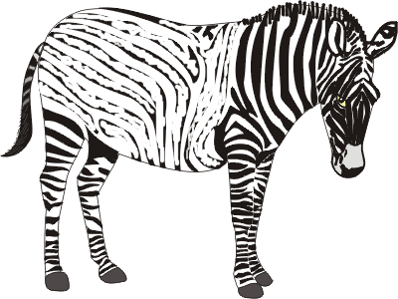
Hi ! I’m Joey.
Color a stripe each time you have a talk with your mirror.

